**ASSIGNMENT 2**

**(Points: 25)**

**(Due: Monday, February 11 by 4:25 p.m.)**

Please complete the following step-by-step instructions in order to complete this assignment:

1. Using Windows *File Explorer* (shortcut is Windows key + e), open the folder named “*CIS 362-001 your full name*” (example: “*CIS 362-005 Ravi Thambusamy*”). Double click to open that folder and then double click to open the *Assignments* folder and add another new folder called “*A2_your_full_name*” (example: “*A2_Ravi_Thambusamy*”).
2. Open the *Android Studio IDE* by double-clicking the shortcut on the desktop.
3. If a previous project is already open in the IDE, click on *File* and then on *Close Project* to close the open project.
4. In the Android Studio welcome screen, click on *Start a new Android Studio project*.
5. In the *Create New Android Project* screen, enter “*Pizza Calories App your full name*” (example: “*Pizza Calories App Ravi Thambusamy*”) as the *Application name*, *your fullname.missouristate.edu* (example: “*ravithambusamy.missouristate.edu*”) as the company domain, and the directory structure you created in *Step 1* as the *Project location*.

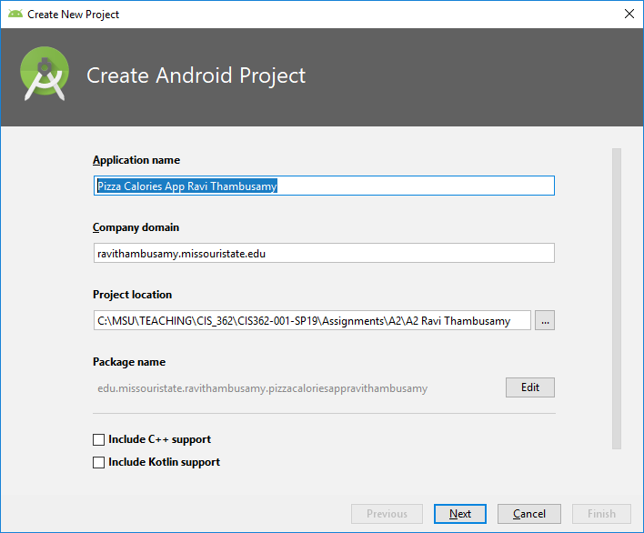

1. Click on the *Next* button.
2. In the next screen, you will be prompted to “*Select the form factors and minimum SDK*”.
3. Drop down the box below “*Phone and Tablet*” and then select “*API 23: Android 6.0 (Marshmallow)*”. Then click on the *Next* button.
4. In the next screen, you will be prompted to “*Add an Activity to Mobile*”, click on “*Empty Activity*” then click on the *Next* button.
5. This will open a “*Configure Activity*” window. Leave the default name in there for the “*Activity Name*” and the “*Layout Name*”. Finally, click on the “*Finish*” button to create the new project.
6. The IDE will open with the *MainActivity.java* source code file as the active tab. Make sure that you see a “*Gradle build finished …*” message in the *status bar*.
7. Click on the *activity_main.xml* tab to make it *active.*
8. Move the *TextView* control to the bottom half portion of the canvas. Use the *Attributes* window to set the *ID* attribute of the *TextView* widget to textViewSelectToppings. Set the *Text* attribute to “Select Your Pizza Toppings”. Set the *TextAppearance* attribute to AppCompat.Large. Make the text appear in bold and italics. Resize the *TextView* control so that its width is more than half of the app’s width.
9. Drag a *CheckBox* widget from the *Palette* onto the *canvas*. Use the *Attributes* window to set the *ID* attribute of the *CheckBox* widget to checkBoxCheese. Set the *Text* attribute to “Cheese (260 calories)”. Set the *TextAppearance* attribute to AppCompat.Large. Next, constrain the *CheckBox* widget appropriately.
10. Drag a second *CheckBox* widget from the *Palette* onto the *canvas*. Use the *Attributes* window to set the *ID* attribute of the *CheckBox* widget to checkBoxMushroom. Set the *Text* attribute to “Mushroom (30 calories)”. Set the *TextAppearance* attribute to AppCompat.Large. Next, constrain the *CheckBox* widget appropriately.
11. Drag a third *CheckBox* widget from the *Palette* onto the *canvas*. Use the *Attributes* window to set the *ID* attribute of the *CheckBox* widget to checkBoxBellPepper. Set the *Text* attribute to “Bell Pepper (30 calories)”. Set the *TextAppearance* attribute to AppCompat.Large. Next, constrain the *CheckBox* widget appropriately.
12. Drag a fourth *CheckBox* widget from the *Palette* onto the *canvas*. Use the *Attributes* window to set the *ID* attribute of the *CheckBox* widget to checkBoxPepperoni. Set the *Text* attribute to “Pepperoni (100 calories)”. Set the *TextAppearance* attribute to AppCompat.Large. Next, constrain the *CheckBox* widget appropriately.
13. Drag a *Button* widget from the *Palette* to the *canvas* and place it below the Pepperoni *CheckBox* widget. Use the *Attributes* window to set the *ID* attribute to buttonfindTotalPizzaCalories. Set the *Text* attribute of this *RadioButton* widget to “Find Total Pizza Calories”. Set the *TextAppearance* attribute to AppCompat.Large. Center the *Button* widget on the canvas. Next, constrain the *Button* widget appropriately. Next, set the *Button* widget’s *onClick* attribute to onButtonFindTotalPizzaCaloriesClick. Click on the *Text* tab to switch from *design view* to *text (XML) view*. Scroll down the *XML* *code* and click on the *red* *squiggly* *line* on onButtonFindTotalPizzaCaloriesClick. A new *light bulb icon* will appear on the left border of the text view. Click on the *light bulb icon* and then select “Create ‘onButtonFindTotalPizzaCaloriesClick(View)’ in MainActivity” as shown below.

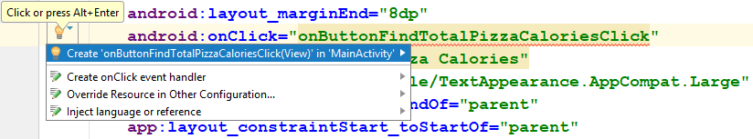

This will add an empty method declaration (header) in *MainActivity.java* as shown below.



1. Click on the *Design* tab to switch back to the *canvas*.
2. The *completed app design* should resemble the one shown below.

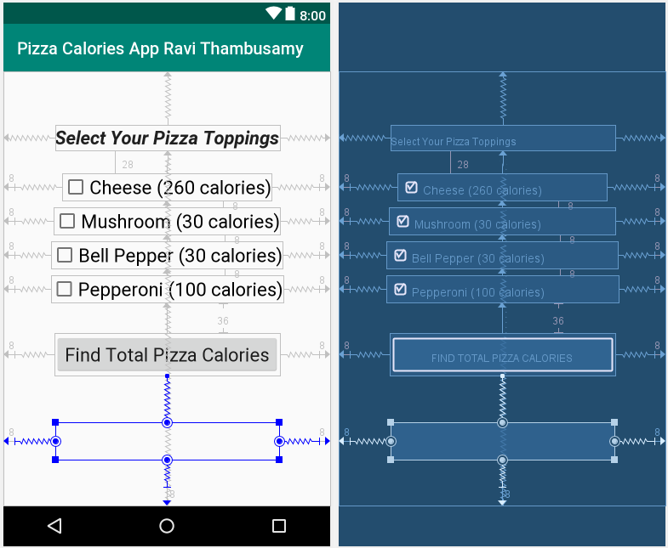

1. In the Android Studio *menu bar*, click on *File* and then on *Save All*.
2. In the Android Studio *navigation bar*, click on the *MainActivity.java* file to make it active.
3. Do the following inside *MainActivity.java*:
4. Declare four class-level constants named CHEESE_CALORIES, MUSHROOM_CALORIES, BELLPEPPER_CALORIES, and PEPPERONI_CALORIES and then do the following:
   1. Set the CHEESE_CALORIES constant’s value to 260.
   2. Set the MUSHROOM_CALORIES constant’s value to 30.
   3. Set the BELLPEPPER_CALORIES constant’s value to 30.
   4. Set the PEPPERONI_CALORIES constant’s value to 100.
5. Declare five *class-level variables* one for each of the four *CheckBox controls* and one for the *total pizza calories text view* *control* on the *canvas* [*Example*: private CheckBox cheeseCheckBox;]. If you see *syntax errors*, click on the words giving you the errors and then click on *Alt+Enter* on your keyboard to get rid of the missing *import* errors.
6. Declare an integer variable called totalPizzaCalories to keep track of the total calories.
7. Inside the onCreate() method, link the *five variables* you declared in the part ii. of this Step to the *five* controls on the *canvas* by using the findViewById() method [*Example*: cheeseCheckBox = findViewById(R.id.checkboxCheese);].
8. Inside the onButtonFindTotalPizzaCaloriesClick(View view) method, do the following:
   1. Set the totalPizzaCalories variable to 0.
   2. Use an if decision structure to check whether the cheeseCheckBox is checked or not. If it is checked, then add the CHEESE_CALORIES constant to the totalPizzaCalories variable.
   3. Repeat the above Step for the remaining three check boxes.
   4. Next, add code to set the *Text* attribute of the totalPizzaCaloriesTextView control to display the text shown in the app output in Step 27.
9. Make sure that there are no *syntax errors* in any part of the project (*.java* or *.xml*).
10. Click on *File* in the menu bar and then click on *Save All*.
11. Click on the *Run app* (green triangle button) in the *toolbar*. Select your *default AVD* and then click on the *OK* button.
12. You should see the following *before* and *after* user input:

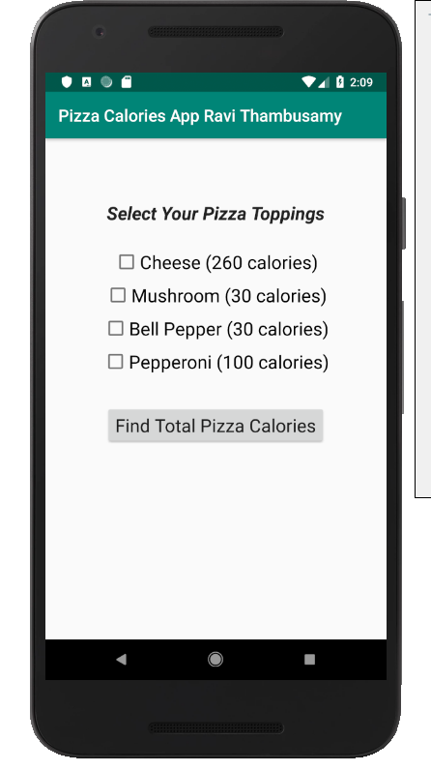 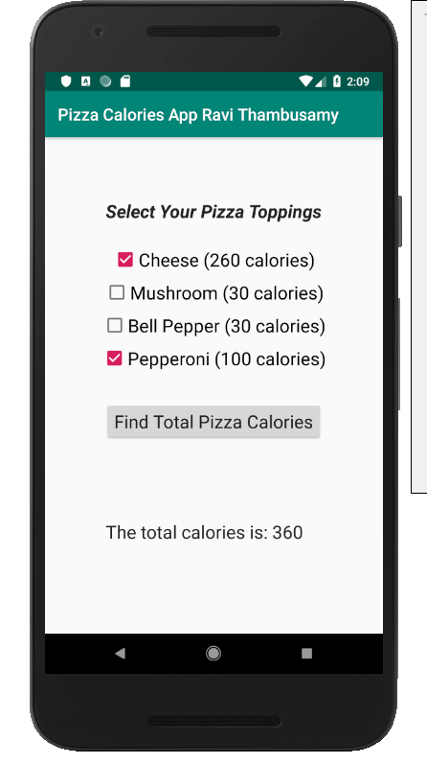

1. Take a *screen capture* of the *emulator*. Open the *Paint* app on your computer and paste the screen capture in there. Save the image file as “*A2 your full name screen capture.png*” inside the directory you created in *Step 1*.
2. Close the *emulator*. Close Android Studio.
3. Use Windows *File Explorer* (shortcut is Windows key + e) to go to the “*CIS 362-001\Assignments*” directory you created in *Step 1*.
4. Click on the “*A2_your_full_name*” directory to select it. Next, click on the *Share* menu in *Windows File Explorer*.
5. Click on the *Zip* icon.
6. Leave the file name as it is and hit the *Enter* button on your keyboard to finish creating the *zip file* for this assignment.
7. Now, log on to Blackboard and click on the “*Assignments*” link under the “*Course Evaluation*” section heading.
8. Next, click on “*Assignment 2 (Due: Sunday February 17 by 11:59 pm)*” link upload this file on Blackboard.
9. In the “*ASSIGNMENT SUBMISSION*” section, click on the “*Browse My Computer*” button. In the *File Upload* dialog box that opens up, navigate to the *CIS 362-005\Assignments* folder and then select the “*A2_your_full_name.zip*” file and then click on the *Open* button.
10. Finally, click on the *Submit* button on Blackboard to complete the submission. Always verify that your zip file has correctly uploaded on Blackboard. If you submit the wrong zip file, then you may not be given a second chance to resubmit the assignment.